 | Procedure Oriented Programming | Object Oriented Programming
Divided Into | In POP, program is divided into small parts called functions. | In OOP, program is divided into parts called objects.
Importance | In POP,Importance is not given to data but to functions as well as sequence of actions to be done. | In OOP, Importance is given to the data rather than procedures or functions because it works as a real world.
Approach | POP follows Top Down approach. | OOP follows Bottom Up approach.
Access Specifiers | POP does not have any access specifier. | OOP has access specifiers named Public, Private, Protected, etc.
Data Moving | In POP, Data can move freely from function to function in the system. | In OOP, objects can move and communicate with each other through member functions.
Expansion | To add new data and function in POP is not so easy. | OOP provides an easy way to add new data and function.
Data Access | In POP, Most function uses Global data for sharing that can be accessed freely from function to function in the system. | In OOP, data can not move easily from function to function,it can be kept public or private so we can control the access of data.
Data Hiding | POP does not have any proper way for hiding data so it is less secure. | OOP provides Data Hiding so provides more security.
Overloading | In POP, Overloading is not possible. | In OOP, overloading is possible in the form of Function Overloading and Operator Overloading.
Examples | Example of POP are : C, VB, FORTRAN, Pascal. | Example of OOP are : C++, JAVA, VB.NET, C#.NET.
Difference Between Procedure Oriented Programming (POP) & Object Oriented 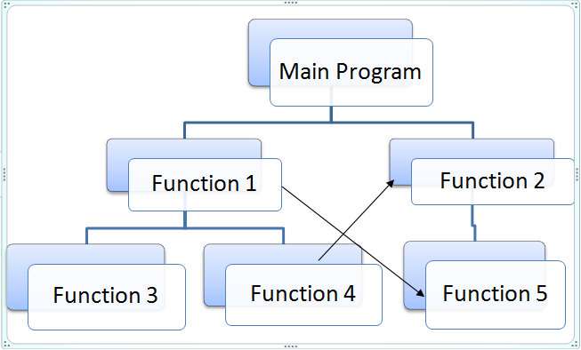 Programming (OOP) 